**EMPLOYEE TRAVEL BOOKING PROJECT**

**INTRODUCTION**

This document outlines a project for the .NET Track. The project is to develop Employee Travel Booking. This document contains the requirements, work flow of the system and gives guidelines on how to build the functionality gradually in each of the course modules of the .NET LOT.

**PROBLEM STATEMENT**

**OBJECTIVE**

Need to develop Employee Travel Booking

**Abstract of the project:**

Employee Travel Booking Application allows Employees to place requests for booking business travel tickets.

In current corporate world, Employees are often required to travel to Domestic as well as international locations based on business requirements. This application “Employee Travel Booking Application” will help employees to raise or submit a ticket for travelling to the required location.

Employee Travel Booking System is an online system which will automate the process of raising or placing a travel requests. Employees will raise or place the travel request. Manager can approve, reject the request. Once manager approves the request travel agent will confirm the travel or can make the status as Bookings not available.

Phase 1: Create simple basic structure for class object and relation using Class Library and Console Application Project.

The system should allow the following functionality:

1. Add Employee, Assign manager

2. Change Manager, Delete Employee.

3. Add/Edit Travel Agents

4. Check current requests submitted and see the status

5. Raise new travel request

6. Cancel the request made.

7. Approve or Reject the travel request raised by Employee

8. Check the history of requests made by reporting employees.

9. Once Manager approves the travel request of employee, travel agent will

change the status to “Ticket Confirmed” or “No Availability” status.

a. Develop the prototypes for following functionalities:

i. **Add/Edit/Delete Employee Screen**: User should be able to add or edit Employees

ii. View/Raise**Travel Request screen**: Employees should be able to enter From

Location, To Location and Travel data and click on ‘Submit’ button to

raise a travel request.

iii. **Approve/Reject Travel Request Screen**: Once employee successfully places travel

request, it can be approved or rejected. Also,

reports of total number of requests received and respective status can be viewed. –

Currently for console application, we are considering only one user

iv. **Booking Screen**: Once the request is approved, based

on availability travel agent can change the status to “Booking

Confirmed” or “Booking Not available”.

b. Develop business components (C# classes) for the following functionality:

1. **User Class** :- This class will contain methods which will allow to manage all employee
2. **TravelRequest class** :- This class will contain methods to manage Travel Requests

**PROJECT STRUCTURE**

**Description**: Create below sample reference project structure, which will help to reuse most of

module for Console application. You are allowed to bring your own project structure and project

to achieve the requirement.

All project should have minimum target framework to – .Net Core

**Design guidelines**

• All the exceptions/errors to be captured and user-friendly message to be

Displayed

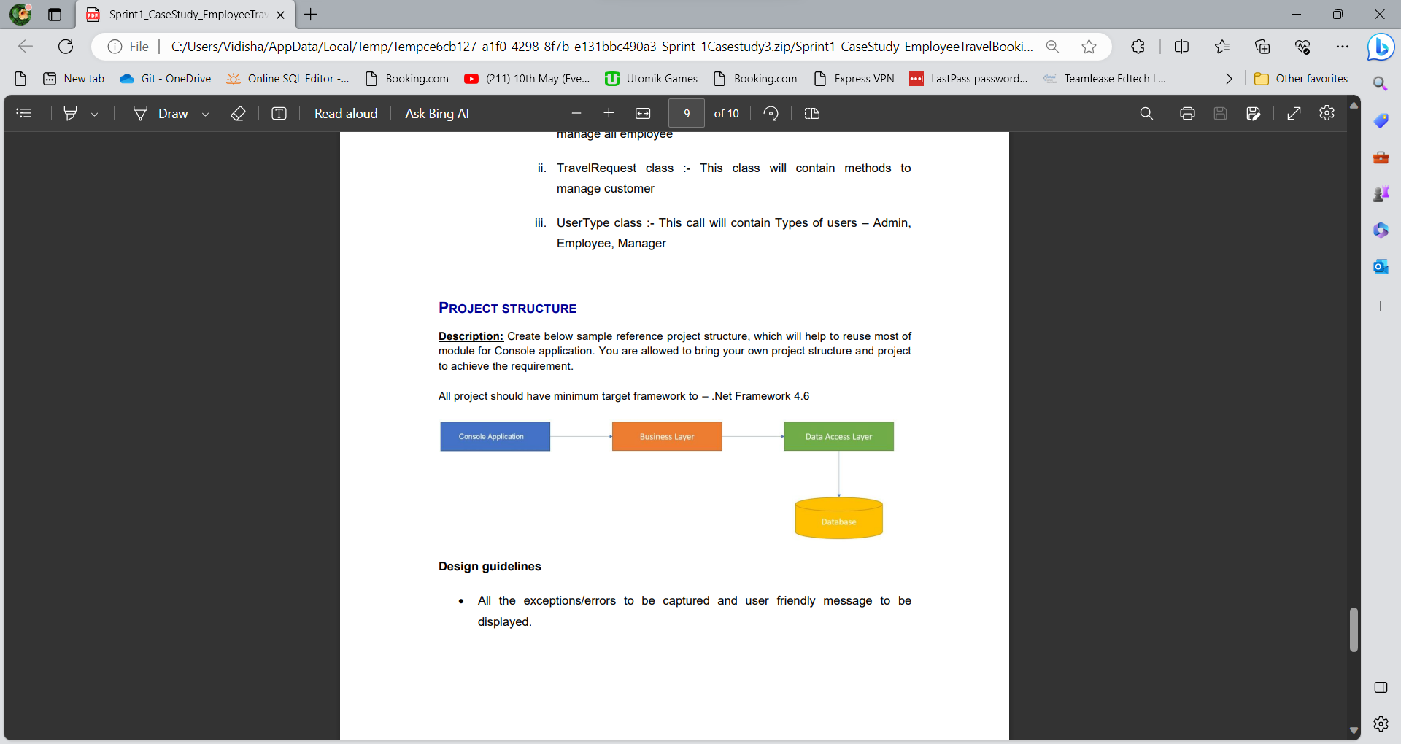

**Design guidelines**

• All the exceptions/errors to be captured and user-friendly message to be displayed.

**IMPLEMENTATION**

**SUMMARY OF THE FUNCTIONALITY TO BE BUILT:**

The participants need to develop the Employee Travel Booking System by building the

functionality incrementally in each of the course modules of .NET